X ROTARY CAMP SIERRA DE
GUADARRAMA (Madrid)

From July 30th to August 12th 2018

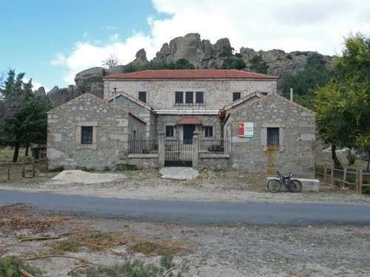

Sponsored by the Rotary Club of Majadahonda in collaboration with the Rotary Clubs of Madrid and Castilla-Leon (SPAIN)

PROGRAMME DETAILS

PARTICIPANTS: | 25 students (one boy and one girl ONLY per country.
AGE: | 18 – 25 years old
DATES: | 30th July to 12th August, 2018
ACCOMMODATION: | Casa de la Cueva Youth Hostel (Peguerinos, Ávila) and U Hostel (Madrid)
PROGRAMME: | Nature and culture
LANGUAGE: | Spanish / English
AIM: | To encourage friendship and understanding among people from different backgrounds and cultures.
CLOSING DATE: | Applications should be received by 15 th May, 2018
INSURANCE | All participants are responsible for their medical insurance policies, according to the guidelines in Rotary International Code of Policies on Travel Insurance for Students, which covers illness, accident, third party damages and personal effects. European participants should bring their European Health Insurance Card.
ACCEPTANCE AND PAYMENT: | Students will be accepted provisionally upon receipt of a scanned application form with two passport size photographs on a first come first served basis, allowing for a gender balance.
CAMP FEE: | 420 Euros. Preferred method of payment is by transfer to the “Club Rotario de Majadahonda”,  Swift / BIC CSPAES2L  Account ES93-2108-4832-0700-3346-5710  but it could also be paid in cash upon arrival at the CAMP.
 | We advise participants to bring some pocket money for their personal expenses.
APPLICATION: | Send your application to Ángel Blanco: Camp.2018@canhispania.com with a copy to: cl@spainrye.es
ARRIVAL: | 30th July, 2018 (between 10 am and 2 pm preferably)  Place: Madrid U Hostel  Sagasta, number 22  28004 - Madrid
12th August, 2018 (from 10 am onwards)
DEPARTURE:

PROGRAMME

30thJuly (Monday) | Arrival to Madrid. Gathering at: Madrid U Hostel, Sagasta 22, 28004 - Madrid). Welcome dinner
31st July (Tuesday) | Guided tour of the Royal Palace
1st August (Wednesday) | Visit to Avila
2nd August (Thursday) | Swimming Pool and sports activities
3rd August (Friday) | Visit to Segovia
4th August (Saturday) | Rotary Day
5th August (Sunday) | Trek to Mount Abantos
6th August (Monday) | Swimming pool and fun activities
7th August (Tuesday) | Visit to Salamanca
8th August (Wednesday) | Fun and sport activities
9th August (Thursday) | Visit to El Escorial and Majadahonda,
10th August (Friday) | Gymkhana and international dinner
11th August (Saturday) | Walking tour of Madrid
12th August (Sunday) | Breakfast, good bye and return home

OBJECTIVE
We intend to offer participants an enjoyable time that includes cultural activities and the practice of different sports, surrounded by nature up on the hills near Madrid.

RULES
In order to guarantee the correct functioning of the camp, we have established some general rules:
- Be on time for the activities
- Take part in all activities
- Keep the house and rooms clean and tidy
- Follow activity leaders’ instructions
- Maintain a good relation with the other students
- Respect nature and follow our moto:

Treat others the way you would like others to treat you

LIST OF THINGS TO BE BROUGHT
- Student Card (extremely important)
- Sleeping bag
- Towel
- Hiking boots or trainers and socks
- Swimming clothes (costume and sandals)
- Jumpers or fleece (temperatures can go down to 10º C at night)
- Long trousers
- Toilet bag
- Torch and water bottle
Bear in mind that we will alternate day trips to towns with hiking and sports days. Therefore, plan your luggage accordingly.
Optional: you can bring some traditional products from your respective countries to prepare something for the International Dinner, if you wish.

CONTACT DETAILS:
Carmen López-Videla Ángel Blanco Telf.: 34 915 487 879
E mail: cl@spainrye.es Camp.2018@canhispania.com

ACCOMMODATION DETAILS
The accommodation during the camp, with the exception of the days of arrival and departure, which will take place at the U Hostel Albergue Juvenil Madrid, Sagasta, number 22, Madrid, will take place at the Albergue “Casa de la Cueva”.
The Albergue “Casa de la Cueva” is situated at 8 km from the village of Peguerinos in Ávila and at 14 km from the El Escorial or from El Alto del León, surrounded by a beautiful pine area which forms the Regional Park of Guadarrama, it is managed by the Association 2001, as well as other existing leisure facilities in the area.
The Albergue “Casa de la Cueva” offers the following:
- 45 vacancies in rooms of four people in bunk beds
- Living room and dining room with a fire place and a barbeque
- Heating as well as hot water by Propane Gas
- Electricity by diesel generator
Because “Casa de la Cueva” is within the Regional Park of Guadarrama bounderies, it is subject to environmental restrictions, such as not having electricity, which is supplied by the diesel power generator, which does not operate between 12 pm to 7 am.
For the same reason, no WI-FI connection is available and the telephone communication is done through mobile network for voice, not having coverage for data.
However, in the all the visits to the various cities, which the programme contemplates, there will normally be voice, 3G data connection (4G in Madrid), as well as free WI-FI in many establishments in the city.

